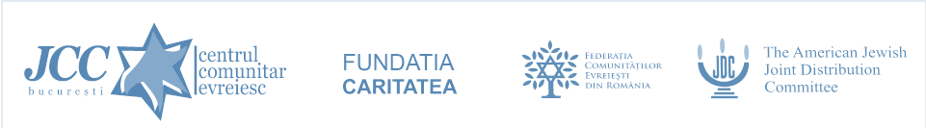
Ibaneh – A Life Changing Seminar
16 – 19 May 2019
Cristian, Brasov

THURSDAY, 16 May
15:00 Departure from Bucharest
19:00 Too Many Choices: What Does It Mean to Be a Jew in the World Today?
20:00 Welcome Dinner
21:00 Fun & Games

FRIDAY, 17 May
09:00 Breakfast
10:00 Something Old and Something New: Innovation and Creativity in Different Jewish Denominations
Break
11:15 Build your own Shabat kit - Arts & Crafts session
12:30 Heading to Brasov
13:00 Visit of the Beit Israel synagogue
Are We All Wicked Sons? Involving Youth in Jewish Life (Session in the synagogue)
14:30 Lunch at the Shalom restaurant
15:45 Departure to Cristian
16:00 Free time & Shabat preparation
18:15 Coffee & sweets
18:30 A Baby-naming in Tel Aviv, Starting School in Morocco: Changes in Israeli Society
19:15 Lighting Shabat Candles
Kabalat Shabat, Carlebach style
Oneg Shabat – part of the Shabat Shalom Romania program
Traditional Shabat Tish

SATURDAY, 18 May
09:00 Breakfast
10:00 Shabat Morning Prayer: Uncovering the hidden message
Prayer does not change God, but it changes the one who prays – (Soren Kierkegaard)
What can the shma and amida teach us about life?
Break
11:15 TeamBUILDING challenge
Break
12:30 Excused or Excluded? Women in Judaism
13:30 Lunch
15:00 Free time
17:00 That'll Show You! Is Anti-Semitism a Reason to Remain Jewish?
Break
18:30 Be the change that you wish to see in the world (Mahatma Gandhi)
To Perfect the World: Theory and Practice
20:00 Dinner
21:30 Havdalah & songs around the bonfire
Motzei Shabat Mesiba

SUNDAY, 19 May
08:30 – 09:30 Breakfast
09:30 How is this night different from all other nights? (Hagada)
The Four Questions as Four Steps in Persona or Communal Change.
Break
11:30 What’s next? Feedback and making plans
Break
13:30 Special lunch in Poiana Brasov
15:00 Departure home

